**USER DEFINED FUNCTIONS (UDF) - BASICS**

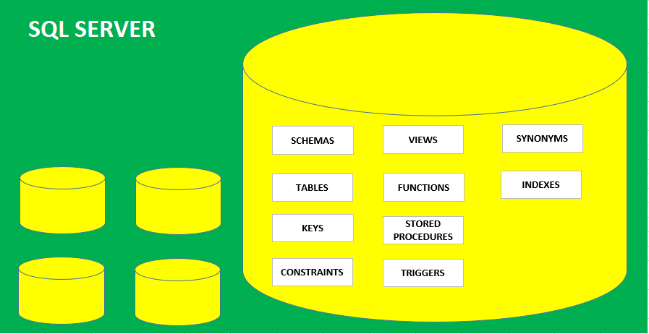

**FUNCTIONS**: DATABASE OBJECTS USED TO STORE **SELECT** & **DML QUERIES**

**PURPOSE** : FUNCTIONS ARE USED FOR CALCULATIONS, DATA ANALYSIS & MONITORING.

**EX**: REPORT LIST OF EMPLOYEES FOR A GIVEN COUNTRY

**EX**: REPORT NUMBER OF EMPLOYEES FOR A GIVEN COUNTRY

**BASIC TYPES OF FUNCTIONS**:

1. **TABLE VALUE RETURNING FUNCTIONS** : REPORTS TABLE DATA (**ARRAY**).

EX: REPORT **LIST** OF EMPLOYEES FOR A GIVEN COUNTRY

1. **SCALAR VALUE RETURNING FUNCTIONS**: REPORT SINGULAR VALUE.

EX: REPORT **COUNT** OF EMPLOYEES FOR A GIVEN COUNTRY

**SYNTAX FOR TABLE VALUE RETURNING FUNCTION**

CREATE FUNCTION <FUNCTION NAME> (@PARAMETERNAME DATATYPE)

**RETURNS** table -- table is a data type

AS

**RETURN**

(

*<< SELECT QUERY OR VALUE >>*

)

**FORMAT FOR EXECUTING TABLE VALUE RETURNING FUNCTIONS:**

*SELECT * FROM <<FUNCTION-NAME>> JOIN.. WHERE … GROUP BY .. ORDER BY ....*

**SYNTAX FOR SCALAR VALUE RETURNING FUNCTION**

CREATE FUNCTION <FUNCTION NAME> (@PARAMETERNAME DATATYPE)

**RETURNS** <<*DATA TYPE*>> -- ANY DATA TYPE OTHER THAN TABLE

AS

**BEGIN**

STATEMENT 1

STATEMENT 2

STATEMENT 3…

**RETURN**

(

*<< SELECT QUERY OR VALUE >>*

)

**END**

**FORMAT FOR EXECUTING SCALAR VALUE RETURNING FUNCTIONS:**

SELECT SCHEMANAME.FUNCTIONNAME(<<PARAMETERS>>)